Vendor guidelines for shipments to
KraussMaffei Extrusion GmbH
(Status 24.11.2020)

Vendor = Supplier
EVS = Exportverpackung Sehnde GmbH

- Introduction
  - Validity
  - Batch parts system

- Information on the delivery note / Partial shipments
  - Information on the delivery note
  - Partial shipments

- Marking / Labelling
  - Shipments to the KraussMaffei Extrusion GmbH logistics service partner
  - Direct shipments to the premises of KraussMaffei Extrusion GmbH

- Preservation

- Customized parts

- Packaging / Loading
  - Packaging
  - Loading

- Excess loading gauge and weight

- Hazardous goods

- Freight at the expense of KraussMaffei Extrusion GmbH

- Accompanying documents / Customs

1. Introduction

1.1 Validity

The present vendor guidelines shall apply to all vendors of KraussMaffei Extrsuion GmbH (KraussMaffei Extrusion) and all shipments to KraussMaffei Extrusion. Any deviations from these vendor guidelines are subject to prior written approval by the logistics or purchasing department of KraussMaffei Extrusion GmbH.

In the event of failure to comply with this requirement, KraussMaffei Extrusion shall be entitled to refuse acceptance of the delivery. In any case, the Vendor shall be charged with all resulting extra costs as well as with a lump-sum amount of at least € 500 per shipment for identification efforts if the packages are not marked as specified herein. In addition, non-compliance will bear a negative effect on the vendor assessment.

All shipments must be exclusively addressed to the delivery address specified in the corresponding order item. This shall also apply to subsequent shipments as well as for deliveries performed during installation, start-up and set-up and in the warranty period. Any modifications of the delivery address shall be made in writing within the frame of a purchase order change by the KraussMaffei Extrusion purchasing department.

Direct shipments of Vendor's contractors to KraussMaffei Extrusion are only admissible in exceptional cases and subject to KraussMaffei Extrusion approval.

The Vendor must ensure compliance with the vendor guidelines by third parties.

In order to facilitate import customs clearance, our logistics department must be notified in advance of shipments from third-party countries.

1.2 Batch parts system

KraussMaffei Extrusion operates a batch parts system with the logistics service partner Exportverpackung Sehnde (EVS).

A batch is the smallest packaging unit of identical materials belonging to a single order and order item.

To ensure a smooth material and information flow from the Vendor to the final KraussMaffei Extrusion customer, each individual part (batch) of a shipment must be marked. Screws and small parts of identical size and type that cannot be provided separately with bar codes must be packed together or bundled in an appropriate manner. In this case, the label will be applied to the outer packaging (see graphic in the annex).

Single parts that cannot be identified or found on site because they were either not correctly marked or not marked at all, must be immediately supplied free-of-charge by the Vendor to the place of use.

For shipments to the logistic center of Exportverpackung Sehnde, the use of the vendor portal “X-Parts Management” of EVS is compulsory. The labels will be provided on the vendor portal of the logistics service partner and must be printed by the Vendor (see Shipments to the KraussMaffei Extrusion logistics service partner).

All shipments addressed directly to KraussMaffei Extrusion shall be identified by labels prepared by the Vendor (see Direct shipments to the premises of KraussMaffei Extrusion).

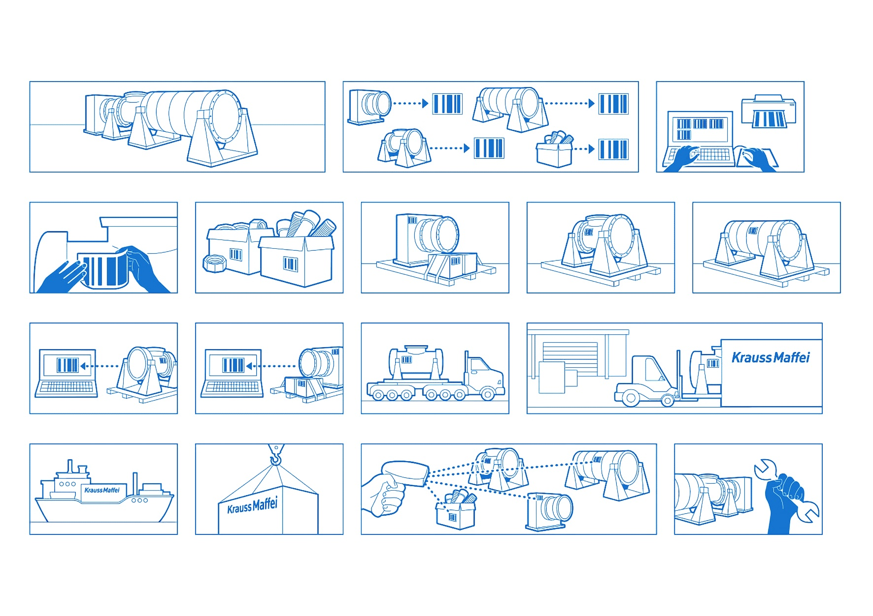
2. Information on the delivery note / Partial shipments

2.1 Information on the delivery note

Delivery notes are handled by means of OCR readers.

For this reason, the printing quality must be clean and clear (laser printer). Please avoid using coloured or grey backgrounds in areas of your delivery notes containing relevant data.

Delivery notes must comprise the following compulsory information:

- Order number
- Order item number
- PSP number, project number and item number, if indicated
- Vendor name and address
- Name and address of the recipient, if no order number is available
- Name of the purchaser specified in the order
- KraussMaffei Extrusion material number
- Delivery quantity
- Quantity unit
- Article or material designation
- Date of shipment
- Information on partial or complete shipment of the order item
- Producer country / origin
- Number of packages
- Customs tariff number / commodity code
- Package data with dimensions, gross and net weight
- Clear reference of the delivery note item to the relevant package

2.2 Partial shipments

Generally, only complete shipments are admissible. Partial shipments are subject to prior agreement with the purchaser. In this case, the partial shipment shall be clearly identified as such and the corresponding value must be specified in the shipping documents.
The information of the complete delivery of the order must be transmitted with the last partial shipment.

3. Marking / Identification

3.1 Shipments to the KraussMaffei Extrusion logistics service partner

All deliveries must be notified at kmbavis@export-verpackung.de at least 3 days in advance. In order to ensure prompt unloading, EVS reserves the right to assign time windows for unloading.

The Vendor will notify the readiness for dispatch using the vendor portal of the logistics service partner.

At least two weeks before shipment, the batches must be entered into the vendor portal of the service partner. The Vendor may contact the logistics service partner for instructions on how to use the vendor portal. The contact data of the service partner are indicated in the order.

The labels are prepared online using the vendor portal of the logistics service partner and printed by the Vendor. For this purpose, suitable printers are specified.

Each batch (as defined in the introduction) must be provided with a separate batch label.

The labels must be securely and visibly attached to allow the bar code to be scanned. In addition, the labels should be weatherproof.

Labels that are directly applied to the product must be removable without any residues.

If the labels cannot be directly attached to the product, they can be sticked on perforated plastic supports and fixed to the batch by means of rotproof cord or galvanized binding wire.

3.2 Direct shipments to the premises of KraussMaffei Extrusion GmbH

The Vendor shall identify all batches to be delivered with the shipping label.

In order to ensure clear identification, the shipping label must comprise the following compulsory information:

- Reference to the delivery note (item number)
- KraussMaffei Extrusion number
- KraussMaffei Extrusion order item
- KraussMaffei Extrusion material number
- KraussMaffei Extrusion material designation (German / English)
- Quantity (actual quantity delivered / quantity per package) in the quantity unit specified in the order
- WBS number

The labels must be securely and visibly attached to allow the bar code to be scanned. In addition, the labels should be weatherproof.

Labels that are directly applied to the product must be removable without any residues.

If the labels cannot be directly attached to the product, they can be sticked on perforated plastic supports and fixed to the batch by means of rotproof cord or galvanized binding wire.

4. Preservation (please also refer to Customized parts)

The Vendor is responsible for the appropriate preservation of the delivered products and for antifreeze protection (emptying of water-containing components and adding of antifreeze agents) considering the conditions at the final place of installation.

Bright surfaces (except for rustproof parts) of machines and sub-assemblies that are not processed or machined by KraussMaffei Extrusion require long-term preservation.

Unless otherwise specified in the order, the threads of assemblies with internal threads (e.g. welded sub-assemblies) must be treated with oil and subsequently closed with flangeless plugs before priming/applying the paint coat.
(Example: Essentra Components SR1034 flangeless plugs)

Pipes / lines or other openings must be closed by means of waterproof plastic or metal caps. Inner walls must not exhibit any visible signs of humidity.

The treatment with KSP204 oil or KSP317 wax of Rivolta is recommended for short-term preservation.

The use of Tectyl 506 – EH supplied by Valvoline is recommended for long-term preservation.

5. Customized parts

Bright turned and milled components, sheet metal and welded parts (except for rustproof parts) must be treated with oil unless otherwise specified in the relevant drawings.

All check gauges indicated in the drawings and dimensions subject to compulsory documentation must be recorded in test records and attached to the respective delivery note.

The Vendor agrees to check for all KraussMaffei Extrusion orders whether the change indices on the order correspond to the respective drawing before starting any engineering or manufacturing operations. This requirement shall also apply to repeat parts, if the drawings are already available to the Vendor and are not transmitted again by KraussMaffei Extrusion. The Vendor shall ensure that the parts are manufactured in compliance with the change index indicated in the relevant order.

In the event of deviations, the KraussMaffei Extrusion purchaser in charge must be contacted and the drawing with the correct change index must be requested, if not available.

6. Packaging / Loading

6.1 Packaging

The Vendor shall ensure suitable packaging considering the route and duration of transport, the climate as well as the conditions in the country and at the place of destination.

During transport, storage and use, the packaging must fulfil several functional requirements, such as:

- Protection against physical damage and environmental contamination.
- The transport packaging used must be designed to ensure that the load can be easily and safely held, lifted, handled, put down and stored.
- The requested shipping information and delivery data must be attached in a clearly visible position.

Moveable parts must be provided with mechanical locks.

The load securing instructions must be strictly followed. Lifting points must be marked, instructions for securing and handling during transport must be included in the delivery. Any installed lifting accessories provided for lifting must be equipped with a rotating eye bolt (lock).

Pre-packagings made from wood like crates and non-returnable pallets must conform to IPPC standard / German HPE guidelines or made from plywood.

The parts of each order are to be bundled and packed separately according to the order item. Exception: preassembled components made up of several order items.

If a shipment comprises several orders, each order must be separately packed.

Make sure that each package includes only project-specific parts (different projects must not be combined in one package).

The packages to be supplied must be provided with package numbers (1 of x).

6.2 Loading

At the time of loading, the Vendor shall make available all means and information required, e.g. centres of gravity, supporting structures, fixing material, etc. to ensure safe and proper loading or stowing of the packaged goods. This also implies marking of packages with international symbols (e.g. centre of gravity, lifting points, load locus, lashing point, tip over hazard, etc.).

7. Excess loading gauge and weight

The Vendor shall design, manufacture and pre-pack the machines/components in a manner to enable transport on standard trucks (trailer/tarpaulin truck, taut liner, swan-neck jumbo trailer or mega trailer). Special transports must be avoided.

The maximum package dimensions are: L = 1,140 x W = 210 x H = 230 cm

Maximum package gross weight: 15 t

If the dimensions indicated above are exceeded, large-capacity or heavy transport will be necessary. To prepare special transport, the Vendor shall transmit to KraussMaffei Extrusion the true-to-scale transport drawings no later than three months before the goods are ready for dispatch.

8. Hazardous goods

If the delivery contains hazardous goods, KraussMaffei Extrusion must be notified no later than five days prior to shipment and the entire hazardous goods documentation must be submitted in advance. Hazardous goods must be separately packed and declared.

9. Freight at the expense of KraussMaffei Extrusion GmbH

FCE or EXT shipments must be notified as follows to ensure that freight will be paid by KraussMaffei Extrusion:

General cargo shipments of up to 40 kg must be notified to the UPS service at
phone no. 01806 – 88 26 63 specifying the KraussMaffei Extrusion customer no. 996-983.

Time-sensitive deliveries must be notified to the nearest TNT subsidiary specifying the KraussMaffei Extrusion customer no. 70 31 56 49.

General cargo shipments of up to 2,400 kg must be handled exclusively by our forwarding partner Schenker-Deutschland AG. In this case, the KraussMaffei Extrusion customer no.
363220 and the package details (number, weight, dimensions as well as the order data) must be indicated.

The nearest Schenker subsidiary can be found on the Internet at: www.schenker.com

Partial or complete shipments must be notified to the shipping management of our forwarder Schenker Deutschland AG no later than three days prior to shipment indicating the package details (number, weight, dimensions as well as the order data) hannover.kundenservice@dbschenker.com.

10. Accompanying documents, customs

In his capacity as dispatcher, the Vendor is responsible for the complete and proper preparation of all transport documents.

All shipping documents (e.g. way bill, delivery note and customs documents, if required) must be completely handed over together with the goods to be delivered.

The Vendor shall make available all documents required for export and import customs handling including preferential origin certificates and national certificates of origin, if required. In addition, all country-specific documents and safety regulations must be taken into consideration. Please advice shipment information and docs per email to Kmeimport@kraussmaffei.com.

Documents | European Union | Third party country incl. EFTA
 | Country | Country | Air | Sea
Delivery note | X | X | X | X
Customs tariff numbers / Commodity codes on delivery note | X | X | X | X
Way bill (CMR) | X | X
AWB (Air Way Bill) |  |  | X
B/L (Bill of Lading) |  |  |  | X
Commercial invoice / Proforma invoice |  | X | X | X
EUR. 1 / A. TR / UZ Form A / Declaration of Origin on invoice |  | X | X | X
Supplier's declaration / Long-term supplier's declarations * | X
Certificates of origin | X | X | X | X
Packing list |  | X | X | X

* This document must be placed at B KraussMaffei Extrusion's disposal and need not be included in single shipments.

In the following cases, the contractor shall inform the KraussMaffei Extrusion customs department by mail to: Exportkontrolle@kraussmaffei.com:

- The delivered products are subject to export control, in particular to the EU dual-use regulation.

- For US products or products with an essential US share it must be indicated whether the product / material is subject to the American Export Administration Regulations (EAR) or not.

